PROBLEM 2:

Submit a document containing a screen snapshot of your dashboard after step 36 showing the Map visualization.

Top of Form

[Upload File](https://www.coursera.org/learn/business-intelligence-tools/peer/9p6Mf/assignment-for-module-2-world-wide-carbon-emissions-scenario/submit)

Bottom of Form

ANS: After step 36, the map is like below:

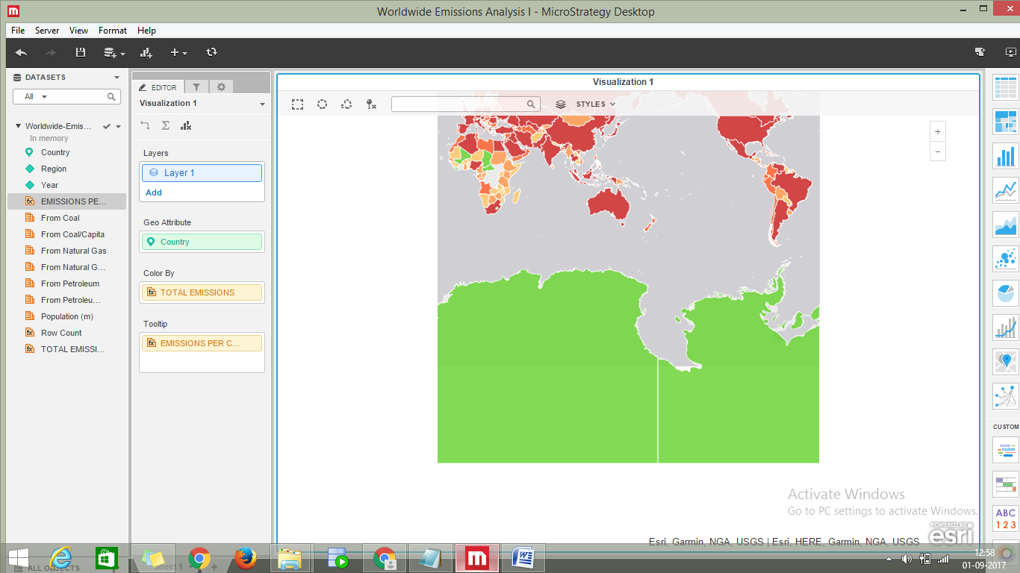

Top of Form

[Upload File](https://www.coursera.org/learn/business-intelligence-tools/peer/9p6Mf/assignment-for-module-2-world-wide-carbon-emissions-scenario/submit)

Bottom of Form